

pIWIK PRO SHAREPOINT analytics – INSTALLATION

SharePoint Server

Version 3.0.2

Contents

1. Introduction 3

1.1. Purpose of this document 3

1.2. Prerequisites 3

2. Install Piwik PRO components in SharePoint Server 3

2.1. Provision SharePoint components 3

2.2. Configure Piwik PRO connection 4

|  |  |  |  |
| --- | --- | --- | --- |
| **Date** | **Version** | **Author** | **Description** |
| 07.05.2020 | 1.0 | P. Hawrylak | Document creation |
| 8.02.2021 | 3.0.2 |  | New function – activate tracker on old sites + variables |
|  |  |  |  |
|  |  |  |  |
|  |  |  |  |

# Introduction

## Purpose of this document

The document describes how to install Piwik PRO resources in SharePoint Server.

## Prerequisites

Before proceeding further please ensure that you have RDP access to SharePoint Server and SharePoint Farm Admin account.

The installation process requires following PowerShell modules and command line interfaces installed on server:

* PnP PowerShell 3.23.2007.1+: <https://docs.microsoft.com/en-us/powershell/sharepoint/sharepoint-pnp/sharepoint-pnp-cmdlets>

If these modules are not installed, they will be installed automatically by deployment scripts

**For Sharepoint 2019:**

* Need to create and register AppCatalog:

To do this please go to Central Administration of Sharepoint 2019,

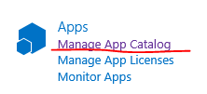

Go to Manage App Catalog,

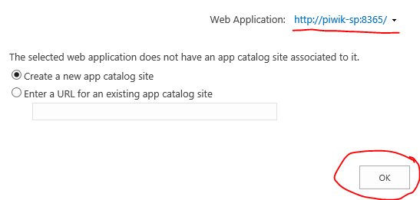

Select Web Application that will be used for tracker and click “OK”.

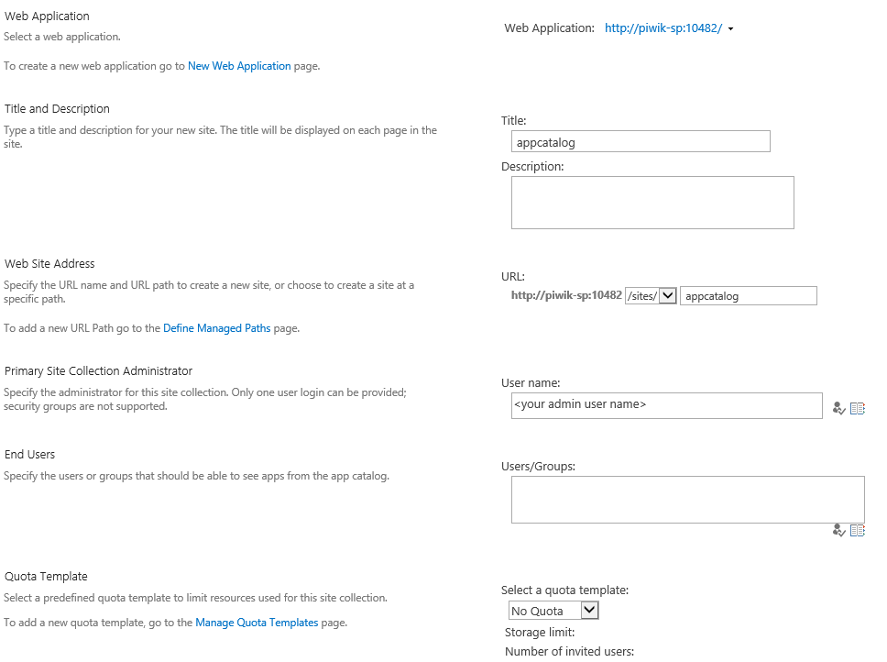

Then put properties like in the screenshot above (in the user name please put user admin with format domain\id) and put OK.

# Install Piwik PRO components in SharePoint Server

## Provision SharePoint components

1. To provision SharePoint components, run Windows PowerShell on SharePoint Server as farm administrator in the context of the SharePoint folder in the installation directory.
2. Open script **Provision-ToSharepoint.ps1** in any text editor like notepad

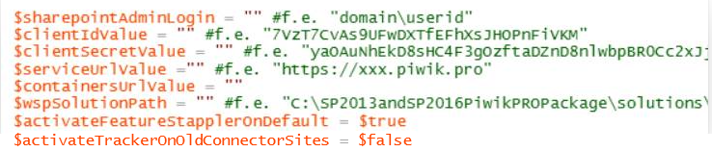

And set the variables above. Description of the variables:

$sharepointAdminLogin - farm admin with format: domain\userid  
$clientIdValue - it is client id from Piwik PRO  
$clientSecretValue - it is client secret code from Piwik PRO  
$serviceUrlValue - your site in Piwik PRO  
$containersUrlValue - it could leave as is or set it if you have special configuration for Piwik Container,  
$wspSolutionpath - like in the example there is a psychical path to the solution file,  
$activateFeatureStapplerOnDefault - $true if you want to activate feature tracking of all new site collections, it activates only feature of tracker (which add custom action to settings menu “Piwik PRO Settings) but not the tracking. Activation on tracking is inside this form,  
$activateTrackerOnOldConnectorSites – this option is only if you have installed old Piwik PRO tracker and you want to enable tracker on the sites where old tracker was enabled before. If this variable is set on $true, during the installation the script will activate the new tracker on the sites where old tracker was exists.

1. Run Provision-ToSharePoint.ps1 script and provide correct parameters, e.g.:

*.\Provision-ToSharePoint.ps1 -SharePointUrl "https://contoso.sharepoint.com" -SharePointVersion “2013” -Owner "CONTOSO\user" -SharePointTenantAdminUrl "https://contoso.sharepoint.com/sites/tenantadmin"*

Parameters:

* SharePointUrl (required): URL to SharePoint
* SharePointVersion (required): Version of SharePoint (2013, 2016, 2019 or Online)
* Owner (required): login of the user that should be the owner of Piwik PRO Administration site collection
* SharePointTenantAdminUrl – url to the tenant admin, it is used by Sharepoint PnP connection, if there is no tenant admin site please put your main site + /sites/tenantadmin, for example: *"https://contoso.sharepoint.com/sites/tenantadmin"*

1. Script should create Piwik PRO Administration site and deploy solution without any error.

## Configure Piwik PRO connection

1. Open Piwik PRO Administration site in SharePoint (https://[your-SharePoint-URL]/sites/PiwikAdmin).
2. Click Settings wheel in upper right corner and open Piwik PRO Settings.

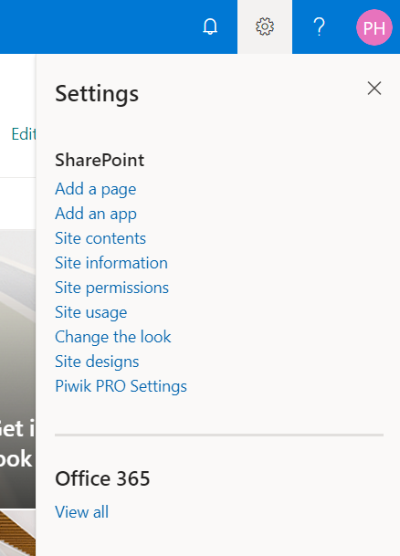

1. Go to Connection Settings tab.

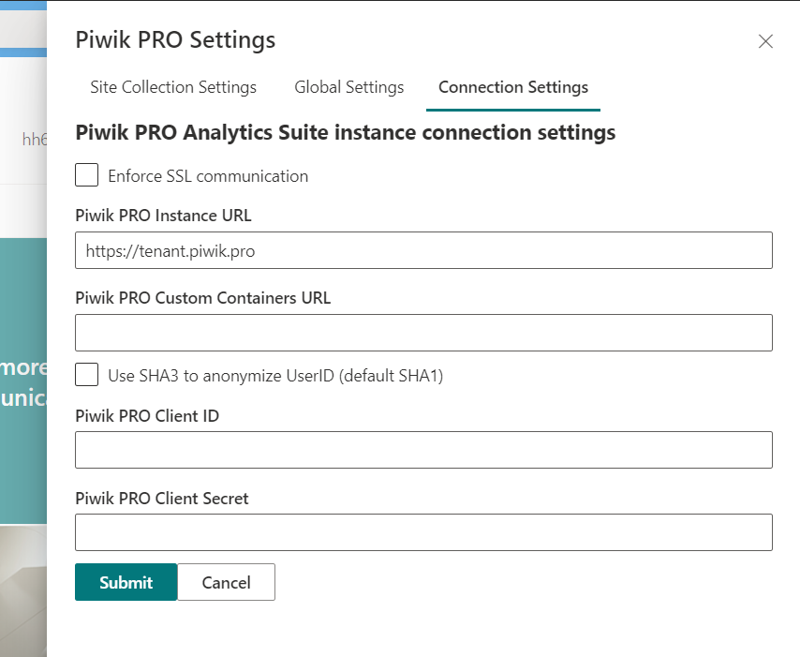

1. Provide URL of your Piwik PRO Instance and Client ID and Client Secret generated in Piwik PRO if is not exists there. Piwik PRO Custom Containers URL is optional and should be provided only if needed.
2. You can also configure tracking settings in Global Settings tab – they will be applied by default on all sites that have tracking enabled.